

DEPARTMENT OF COMPUTER SCIENCE AND ENGINEERING

Course: CSE 391
Name: Mhod. Seaumul Islam Khandaker
ID: 22241179
Email: seaumul.islam.khandaker@g.bracu.ac.bd
Project Title: Accessible student life cycle management system

Project Features:
By the end of this course, implemented features:
- Sign up and login for student and administrator
- Voice navigation for accessibility
- Student dashboard with courses and class schedule
- Advising panel for student to add and drop courses
- Admin panel to manage courses and sections

Screenshots:
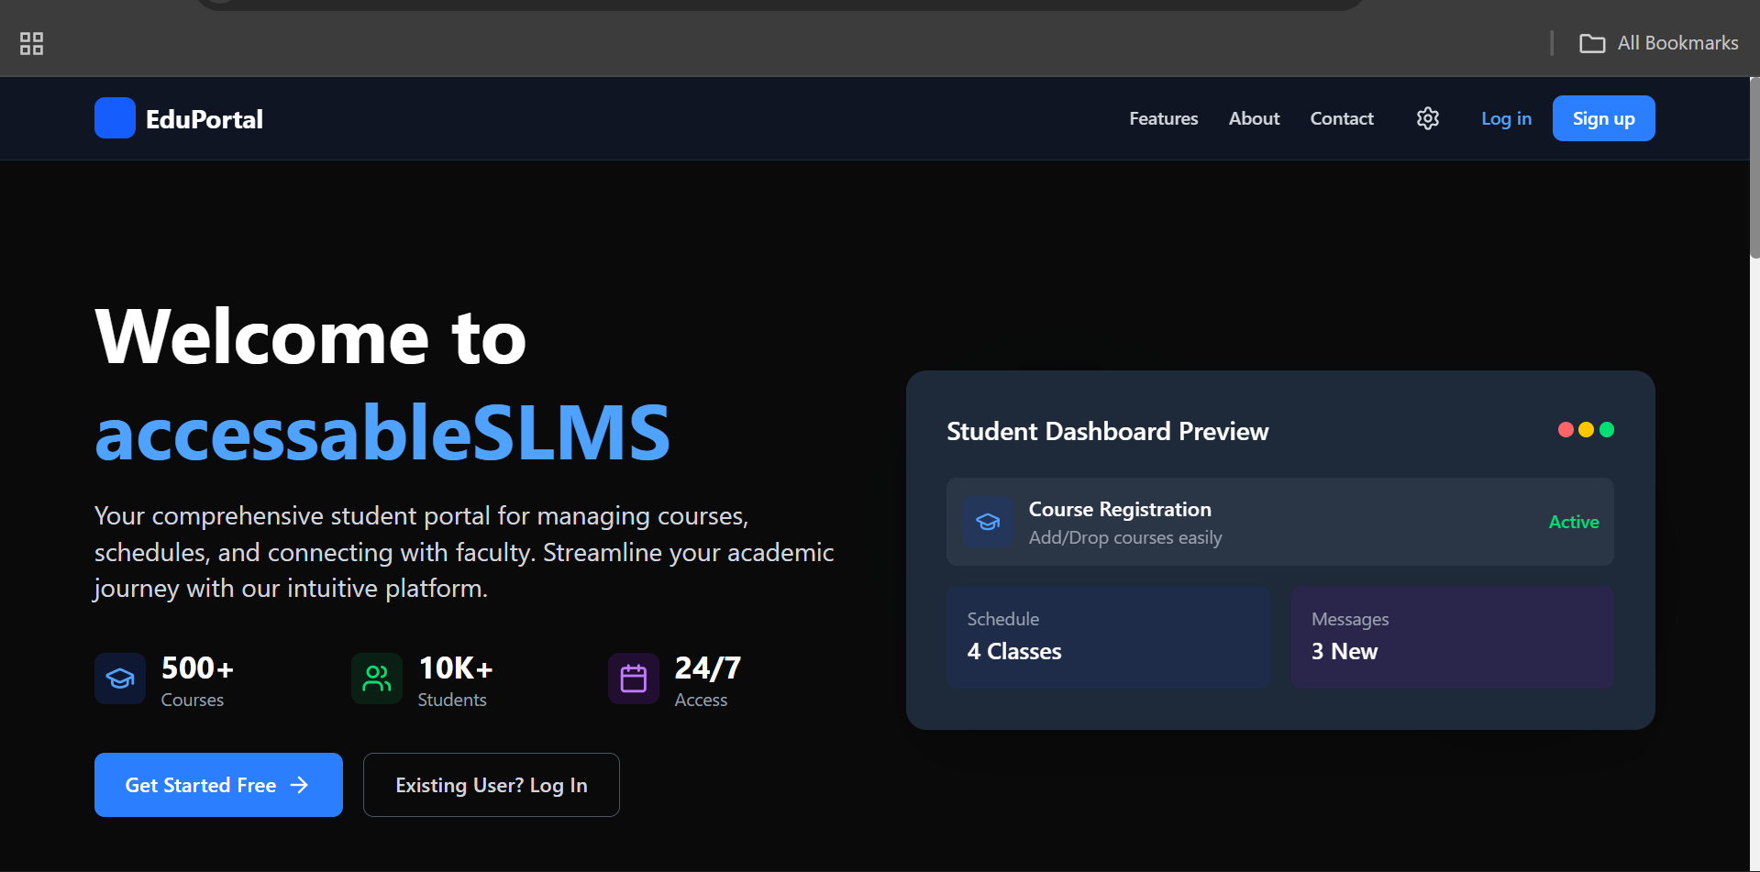

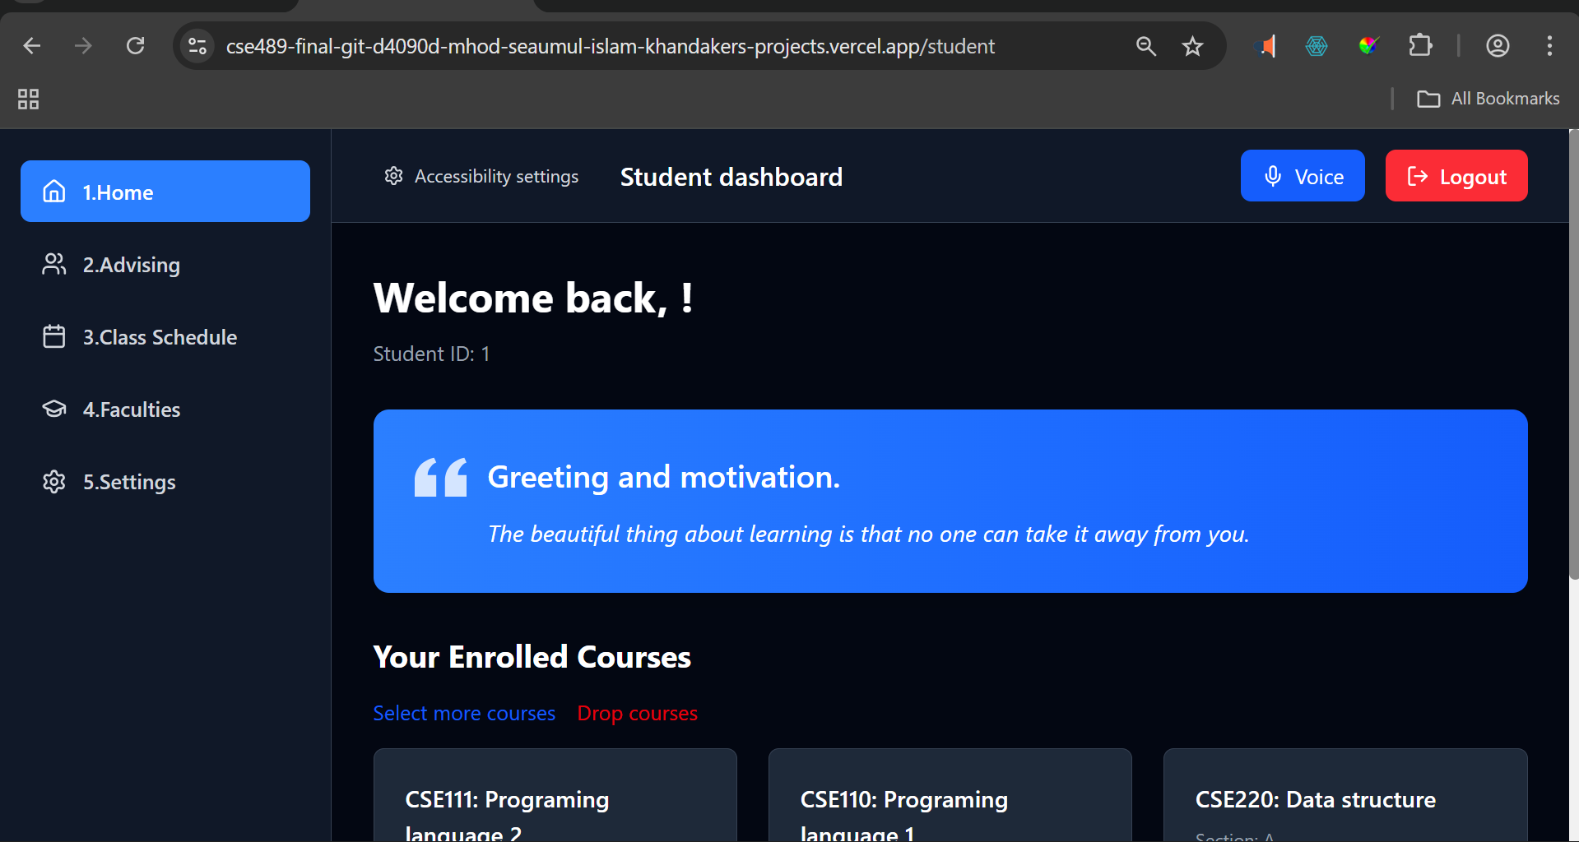

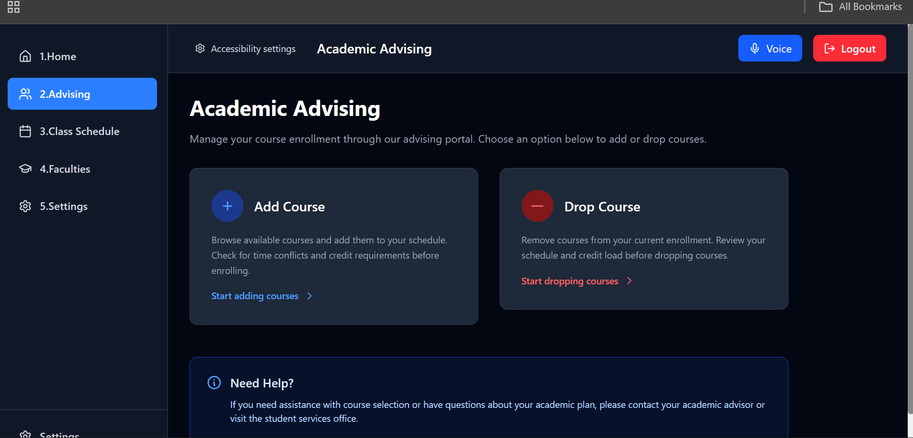

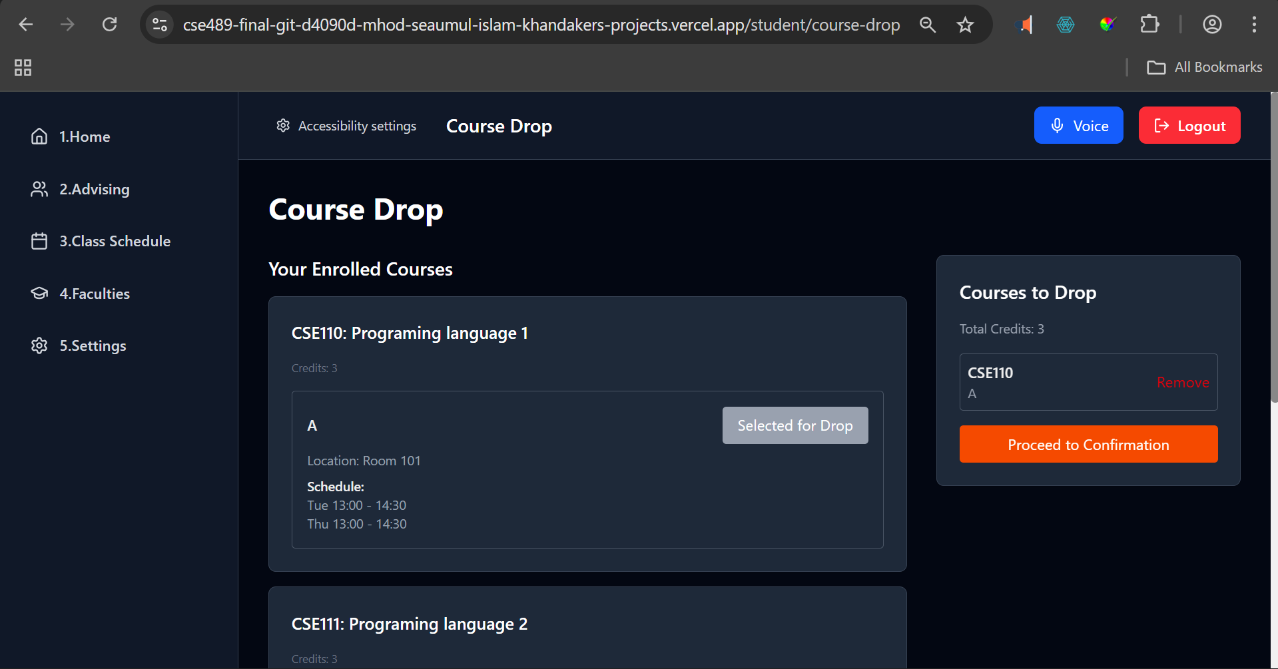

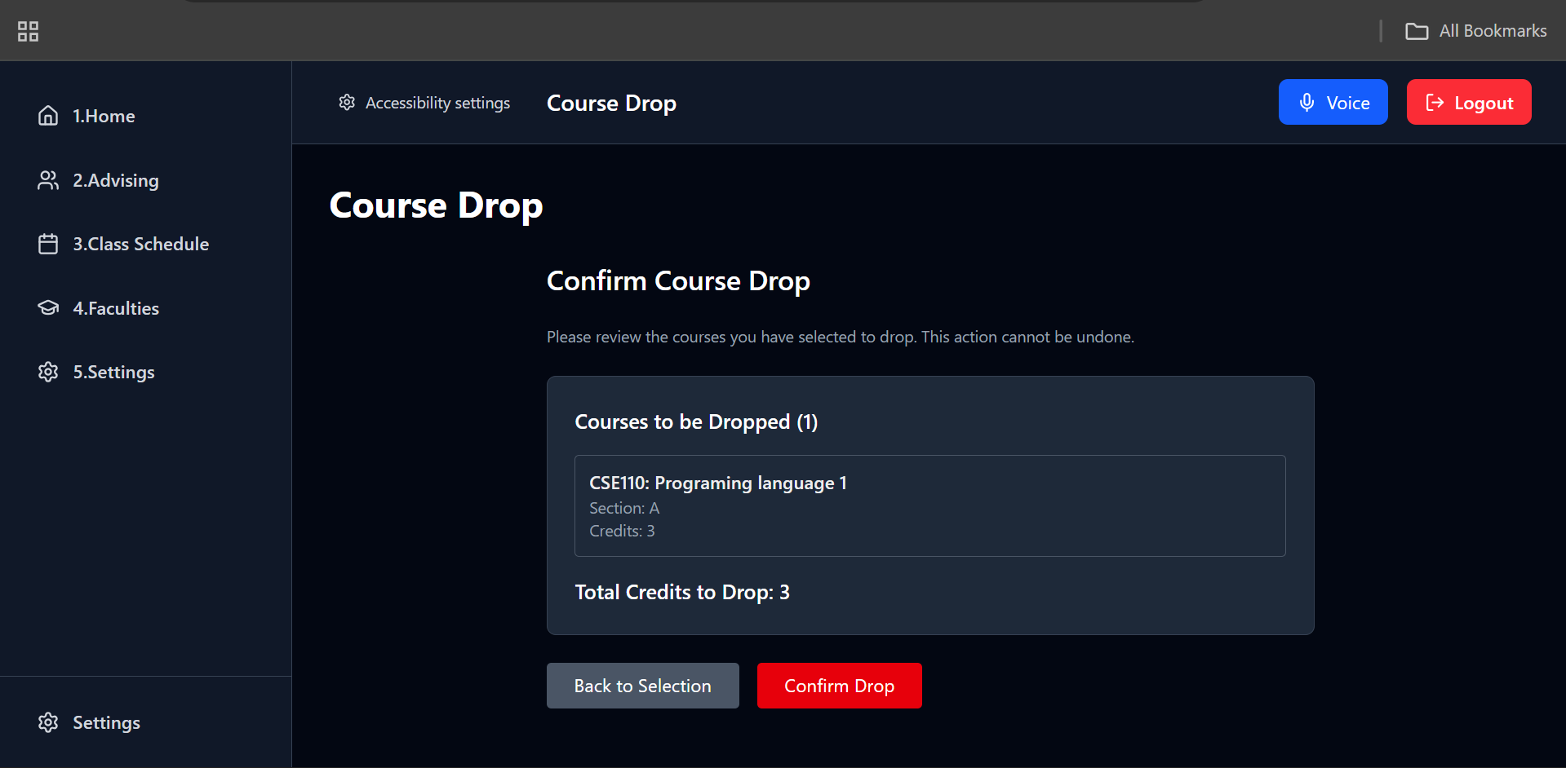
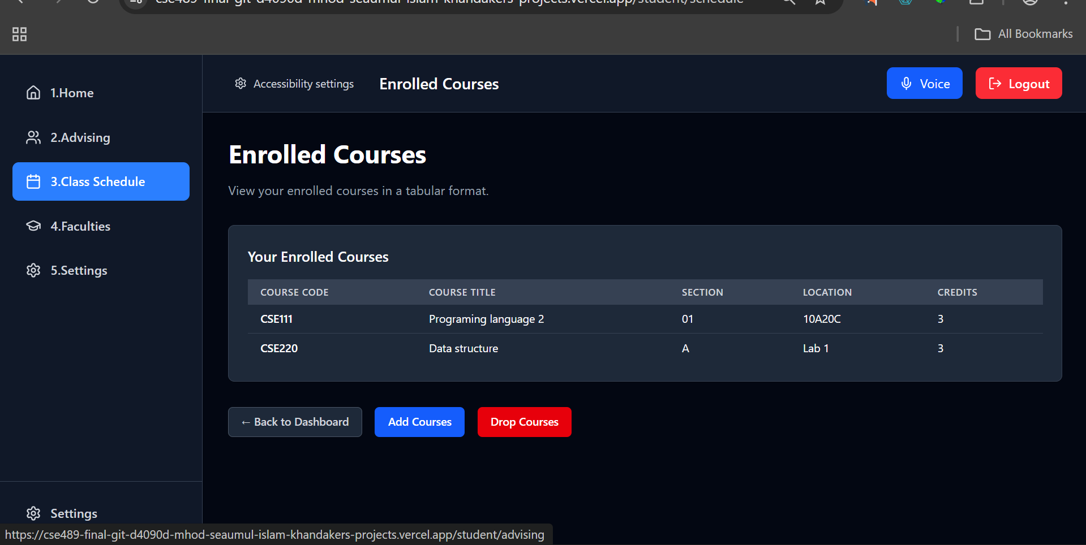
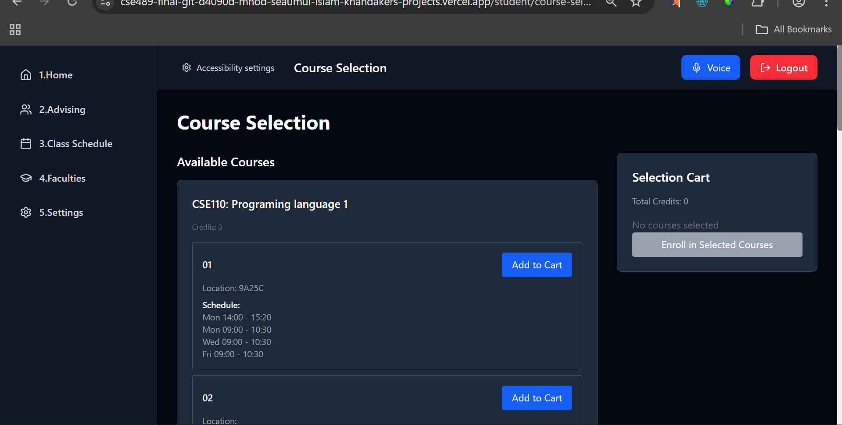

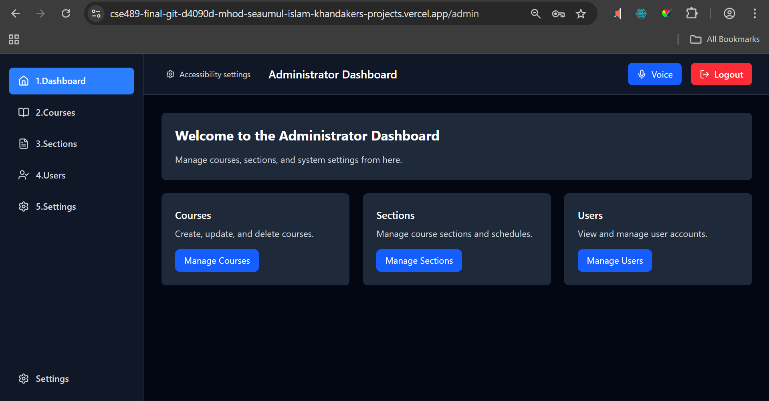

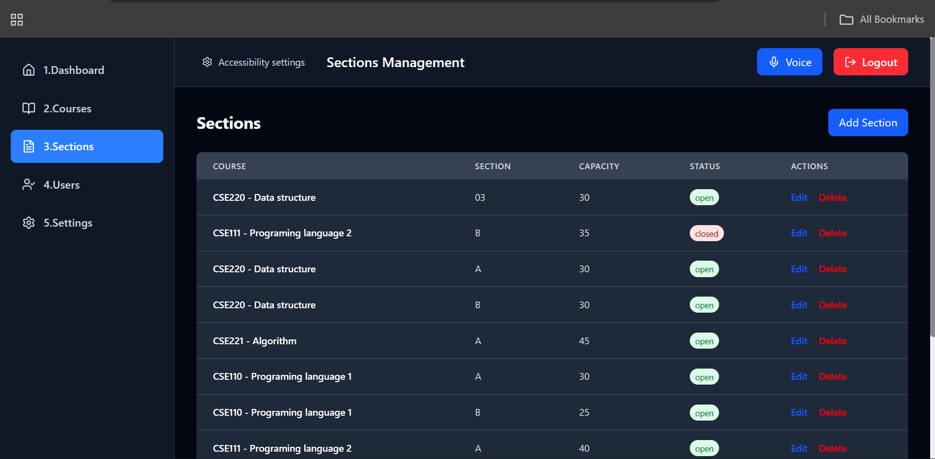

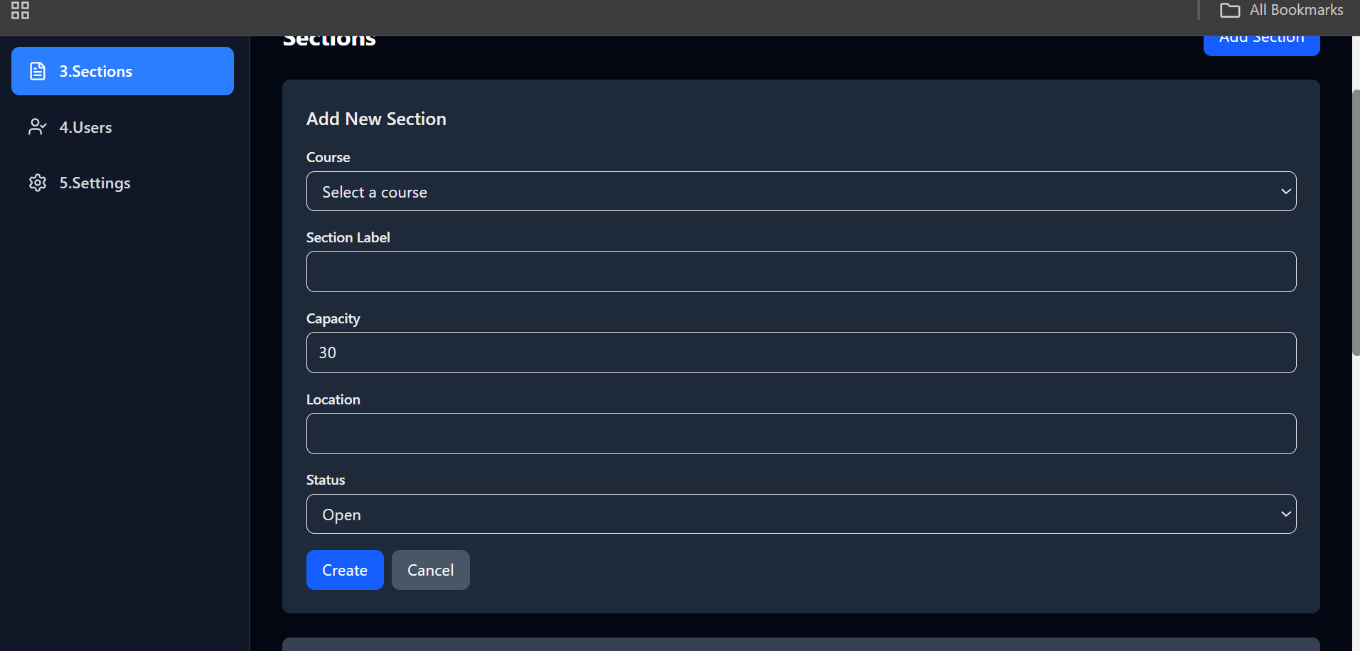

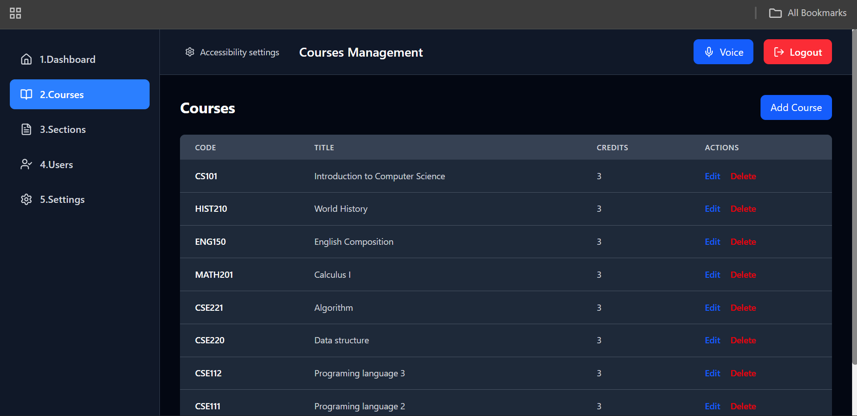

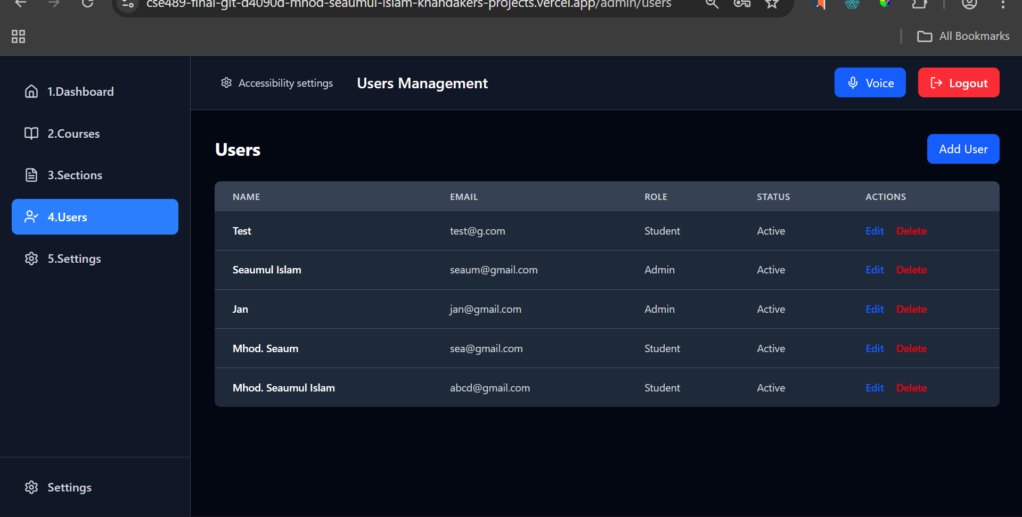
Online Resources used:
a) Reference:
- https://nextjs.org/docs
- Youtube videos https: //www.youtube.com/watch?v=M9O5AjEFzKw
Future Enhancements:
Following enhancement can be added to the current system which will improve the system.
- Student teacher live chat communication
- Settings for advanced accessibility features
- Assignment and quiz submission portal.

